01 April 2014
JKASP8 Sapporo 2014
8th Biennial Workshop on Japan-Kamchatka-Alaska Subduction Processes:
-Finding clues for science and disaster mitigation from international collaboration-
Institute of Seismology and Volcanology and Department of Natural History Sciences
Hokkaido University
Geological Survey of Hokkaido, Hokkaido Research Organization
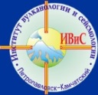
Sapporo, Japan
Second Circular and Call for Abstracts
Abstract and Registration Deadline: 1st June 2014
Abstract and registration forms are attached in last pages

Venue: Hokkaido University, Sapporo, Japan
Date: 22-26 September 2014
Excursion: Taisetsu volcanic field
http://sites.google.com/site/jkasp2014sapporo/home
Welcome to JKASP8! We are kindly inviting you who are interesting in geodynamics and disaster mitigation of Japan-Kuril-Kamchatka-Aleutian-Alaska subduction processes. This biennial unique workshop has been held at Petropavroksky-Kamchatsky, Sapporo and Fairbanks in rotation with warm relation of North Pacific neighbors. You can make scientific reports and discussion of great earthquakes, tsunamis, volcanic eruptions, plate interaction and mantle dynamics emphasizing in North Pacific and surrounding regions thorough presentation and field excursion. Proposals for international and interdisciplinary projects are also welcoming. Disaster mitigation activity through international monitoring of earthquake, tsunami and eruption are also important target of JKASP. Borderless communication during this workshop will give clues to solve and make progress in science and disaster mitigation. Young students/scientists participation is encouraged.
Topics for presentations:
- Recent and past earthquakes, tsunami, seismicity, seismology, tectonics, dynamics, plate motion, subsurface structure, active fault, tsunami deposit, paleoseismology, gravity, etc
- Recent and past eruptions, petrology and geology, geophysical and geochemical observation, volcano seismology, caldera, geothermics, magma genesis, volcanism, etc
- Geopark, alert operation, crisis operation, earthquake early warning, long term evaluation for earthquake and eruption, tsunami warning and monitoring, volcano monitoring, ash plume monitoring, satellite monitoring, aviation alert, hazard map etc

Steering committee:
Mitsuhiro Nakagawa, Hiroaki Takahashi, Sapporo, Japan
John Eichelberger, Pavel Izbekov, Fairbanks, Alaska, USA
Evgeny Gordeev, Victor Chebrov, Petropavrovsk-Kamchatsky, Russia
Abstract Format and Submission: Deadline 1st June 2014
Template file for abstract is able to download from here. Individual format written by MS-word or PDF is also acceptable with a minimum font size of 12 points Times New Roman with 2.5cm margin on all sides. A participant can submit two titles. Abstract volume will be published electrically by PDF format. Please send your abstract with registration form to jkasp@soen.sci.hokudai.ac.jp to being “JKASP” in subject of submission e-mail.
Registration and Visa Application: Deadline 1st June 2014
- Please fill registration form and send to jkasp@soen.sci.hokudai.ac.jp with abstract to be email subject as “JKASP”.
- Russian participants should send passport copy with registration form for visa application. LOC will send visa application form with certification. Russian participants have to apply it to Japanese consulates in Vladivostok, Khabarovsk, Yuzhno-Sakhalinsk or Moscow. Visa preparation process will take more than months. Information from embassy of Japan is http://www.ru.emb-japan.go.jp/VISANDTOURISM/index.html
- Travel expense support is partially available for young participants.
Registration fee:
- Expected registration fee will be \30,000JPY, or equal USD/Rubles which cover group events. Excursion participants have to pay additional fee of approximately \25,000JPY including one night accommodation, foods, ropeway and transportation. Fixed prices of fees will be announced in 3rd circular. Student discount is applicable.
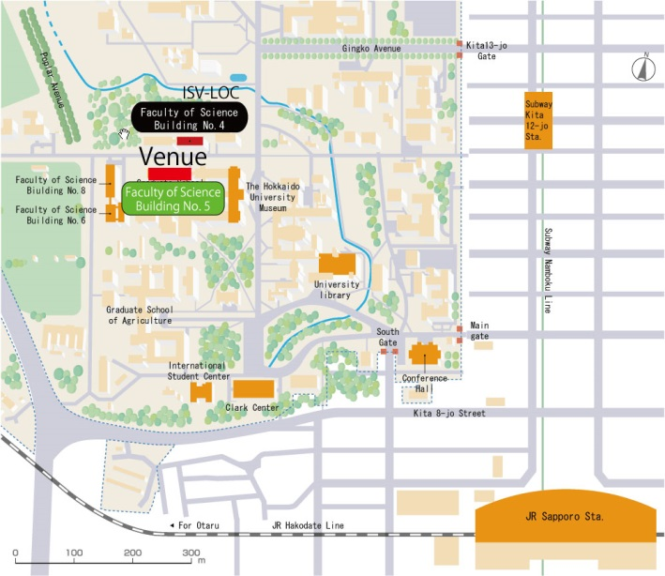
Venue:
Hokkaido University (HOKUDAI)
Faculty of Science Building No. 5
5-203 room (large lecture room)
- 15min walk from Sapporo station
- LOC is in ISV of science building No. 4
Language: English
Accommodation in Sapporo:
Hotels near Hokkaido University are recommended. You can find many hotels from cheap to excellent via internet hotel reservation sites. Cost for one night accommodation is cheaper than $100. If you require assistance, please contact to LOC with your travel information until June 1st.
- General reservation site: “Jalan” http://www.jalan.net/en/japan_hotels_ryokan/
- Toyoko-Inn Hokudai-Mae http://www.toyoko-inn.com/e_hotel/00018/index.html
- Toyoko-Inn Sapporo-Eki http://www.toyoko-inn.com/e_hotel/00066/index.html
- Best Western Hotel http://sapporo.bwhotels.jp/
- Sapporo Aspen Hotel http://www.aspen-hotel.co.jp/english/
- Hotel Keihan Sapporo http://www.hotelkeihan.co.jp.e.gm.hp.transer.com/sapporo/
- Sapporo Crescent Hotel http://crescenthotel.info/en/
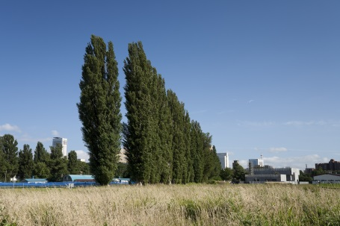
Schedule: (Tentative)
Sep. 22 (Mon.)
10:00-13:00 Registration at Hokkaido University
13:00-13:30 Opening
13:30-17:30 Earthquake, tsunami and tectonics
17:30-19:00 Icebreaker (depend on weather)
Sep. 23 (Tue)
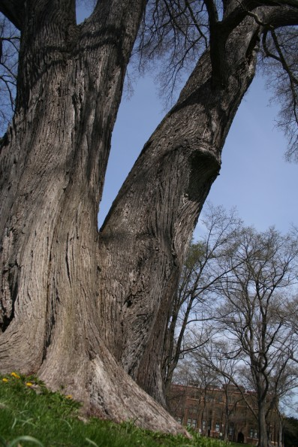
09:00-12:30 Earthquake, tsunami and tectonics
14:00-18:00 Volcanism
18:00-20:00 Welcome reception
Sep. 24 (Wed)
09:00-12:30 Volcanism
12:30-18:00 Move to Taisetsu excursion field
Sep. 25 (Thu)
Excursion at Taisetsu volcanic field
Sep. 26 (Fri.)
14:00-18:00 Disaster mitigation, new international projects, and wrap up
18:00-20:00 Farewell banquet

Excursion:
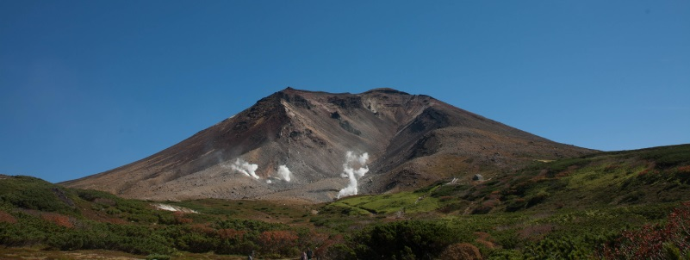
Taisetsu (Daisetsu) volcanic field in central Hokkaido, about 150km away from Sapporo, is a place for group excursion in 24-25 September. You can see Active Asahidake volcano, the highest mountain in Hokkaido (2,291m) and explosive active craters with volcanic complex. Ropeway to middle flank of mountain is in operation. Participants who have good legs can cross mountain summit by a day trekking, and another participants will enjoy autumn fresh air in mountain region easily using ropeway. Weather will be to being cold, about less than 10 degrees temperature, and might be first snow. Participants who will try to climb up to the summit have to bring suitable shoes and waterproof clothes. You can enjoy Japanese style accommodation and hot spring spa (ONSEN). Estimated excursion cost is approximately \25,000JPY. Accommodation of 24 September is arranged by LOC. You do not need to reserve hotel for 24 September in Sapporo if you will participate excursion. We will be back to Sapporo in 25 September evening. You can check volcano information via following JMA catalogues:
Photo by K. Ishige
http://www.data.jma.go.jp/svd/vois/data/tokyo/STOCK/souran_eng/volcanoes/009_taisetsuzan.pdf
Travel information:
New-Chitose (CTS) international airport is nearest and about 40min from Sapporo by rapid train operated in every 15min. New-Chitose airport have direct international flight to Seoul/Incheon (2-3 flights per day), Yuzhno-Sakhalinsk (2 per week), Beijing, Shanghai, and domestic connection to Japanese major international airports. Participants from US can use connection from Tokyo/Narita, Nagoya/Chubu or Osaka/Kansai, and Seoul/Incheon to New-Chitose. Flight information from Russian Far East in 2014 summer period is followings. S7 Airlines have flights from Khabarovsk/Vladivostok to Tokyo/Narita, Aurora Airlines have direct flight from Yuzhno-Sakhalinsk to Sapporo, and will operate to Tokyo/Narita soon. Participants have to confirm latest flight information before planning.
Flights from/to Russian Far East to/from Tokyo/Narita
 | Khabarovsk | Vladivostok
21 (Sun) | S7-0567 Arr. 13:35 | S7-0565 Arr. 12:55
27 (Sat) |  | S7-0566 Dep. 13:55
28 (Sun) | S7-0568 Dep. 14:25
Flights to/from Sapporo
 | Yuzhno-Sakhalinsk
20 (Sat) | HZ-151 Arr. 17:50
27 (Sat) | HZ-152 Dep. 18:40
Weather condition:
September is the best season in Sapporo, comfortable daytime temperature of 18 degree, sunny and dry air and clear sky in early autumn.
Sponsorships:
This meeting will be supported by Institute of Seismology and Volcanology of Hokkaido University, Geological Survey of Hokkaido, Geodynamics project promoted by KAKENHI of JSPS-MEXT, bilateral joint research programs by JSPS.
Contact information:
Secretary-General:
Hiroaki Takahashi, Hokkaido University, Sapporo, Japan
jkasp@soen.sci.hokudai.ac.jp
Russian participants: Oxana Evdokimova, Institute of Volcanology and Seismology, Far East Branch of Russian Academy of Sciences
evdokimova@kscnet.ru
US participants: Pavel Izbekov, Geophysical Institute, University of Alaska Fairbanks
pavel@gi.alaska.edu

Abstract sample form for JKASP 8 2014 workshop - the biennial Japan-Kamchatka-Alaska Subduction Process in Sapporo

Hokudai Taro1, Kazan Ivaschev2, Igor Miyamachenko3

1 Hokkaido University, Sapporo, Japan, taro@jkasp2014.sp.or.jp
2 Kuril University, Matsuwa, Russia, kaz@kuril.ac.ru
3 Bering University of Technology, igor@aleutian.go.un

Title of abstract is written with 14pt Arial Bold. Author name, affiliation and e-mail address are written with 12 pt Arial. Text body is written with 12pt Times New Roman. Figures and tables are available in abstract. No limitation of abstract pages is assigned. Note that total size of abstract is less than 5MB. A participant can submit two abstract maximum, but one oral will be acceptable. Author should indicate oral or poster in registration form.
Abstract and registration forms should be sent together by attached files using e-mail to jkasp@soen.sci.hokudai.ac.jp. Subject of e-mail will be set as “JKASP”. LOC will send a confirmation letter of receiving abstract and registration by e-mail within a week. If you do not receive it, please contact to LOC. We are looking forward to accept your submission.

JKASP2014 REGISTRATION FORM
DEADLINE: 1st JUNE 2014
Participant who request visa application should fill all information and attach passport image. Estimated registration fee: \30,000JPY and approximately \25,000 for excursion. Discount rate will be applied for student.
Full name in passport |  | □Student
Accompanying person
Affiliation/Institution
E-mail address
Presentation title1 |  | □Oral | □Poster
Presentation title 2 |  | □Oral | □Poster
Date of birth (D/M/Y)
Sex(Male/Female) | □Male □Female
Excursion (25-26 Sep.)  Special request (Food etc) | □Full day trekking □Half day stroll using ropeway □No
Nationality or citizenship | For visa application and logistics
Passport type | □Diplomatic □Official □Ordinary □Other
Passport No.
Place of issue
Issuing authority
Date of issue and expiry (Day/Month/Year) | Issue:  Expiry:
JP embassy or consulate general for visa application | □Vladivostok □Khavarovsk □Yuzuno-Sakhalinsk □Moscow □other
Home telephone number
Office telephone number
Intended length of stay
Date of arrival in Japan
Port of entry into Japan
Name of ship or airline
Name and address of hotels with whom applicant intends to stay
Dates and duration of previous stays in Japan
Current residential address
Current position or occupation and position
Address of employer
Comments
Visa application requires months. Though your schedule is not fixed, please send this back to LOC. LOC will ask you necessary information later. Send to: jkasp@soen.sci.hokudai.ac.jp

